Every year, NYC gives away about $600 million in a relatively unknown tax break through the Cooperative and Condominium Property Tax Abatement. More than 320,000 cooperative and condominium homeowners received an average tax break of $1,890 in FY2019 but benefits to luxury homeowners far exceed this average (as shown in the Top 10 Abatement Chart). While this abatement is the 2nd largest tax expenditure in New York City, many homebuyers are unaware of it when they purchase an apartment. Unlike the federal Mortgage Interest Deduction, it does not typically factor into a buyer’s calculation of affordability. Although household income data is not made public for individual abatement recipients, NYC’s Housing and Vacancy Survey indicates that 10% of all coop / condo owners citywide earn more than $350k/year.

NY State Legislation A7092 / S5267, sponsored by Assembly Member Robert Rodriguez and Senator Brian Kavanagh, proposes to renew and reform the Cooperative / Condominium Property Tax Abatement as follows:

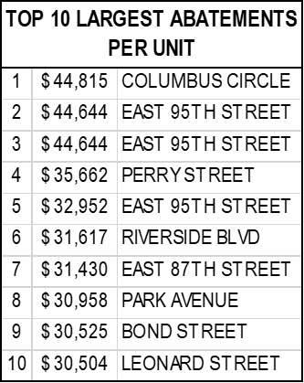
- Renews the Cooperative / Condominium Property Tax Abatement for ~90% of homeowners. Scheduled to sunset in June 2019, this bill continues to reduce the real property taxes for the vast majority of coop / condo owner-occupiers by 17.5% - 28.1%, depending on assessed value.

- Ends tax breaks for the top 10% of luxury properties, with DOF billable assessed value of $200k per unit or more. DOF billable assessed value is a mere fraction of actual market value. Luxury owners, like President Trump, don’t need this abatement (he was eligible for $48k in tax relief when he resided in NYC)!

- Redirects earmarked revenue to #SAVENYCHA. An estimated $3.3 billion in bond financing can be raised with $169 million in projected annual revenue, which will be collected by ending this tax break to luxury owners. This can help close the $8 billion funding gap identified in the NYCHA 2.0 Plan which raises $24 billion towards the $32 billion total capital needs.

CITYWIDE IMPACT ANALYSIS (Estimate as of 5/13/2019)
400,000 NYCHA Residents | $32 Billion NYCHA Capital Repair Needs
324,000 Coop / Condo Units Receiving Abatements in 2019 | $612 Million Total Abatement Amount in 2019
30,000 Luxury Owners Ineligible Under A7092 / S5267 | $169 Million in Redirected Annual Tax Revenue Under A7092 / S5267
Data Reference: NYC Department of Finance data analysis provided by Citizens Housing & Planning Council (chpcny.org).

