- HUD Investment in Families & Communities
  - 48,705 District Residents use HUD Programs.

    - 10,389 Section 8 Vouchers help 17,406 family members afford market rent
    - 9,481 Public Housing Units house 21,426 residents
    - 5,169 privately owned HUD-Assisted units serve 9,873 residents

  - $315.3 million in CDBG funds annually support statewide community initiatives
Affordable Housing Preservation in Midwood

Marien-Heim Tower preserved 182 senior affordable housing units. The 13-story tower and the senior center were revitalized without displacing any of the residents. Renovations include new appliances, energy-efficient boilers, burners, hot water heaters, bathrooms, kitchens, security system, landscaping, windows, façade restoration, updated lobby, laundry room and main entrance.

Federal investments include Tax-Exempt Private Activity Bonds, 4% Low Income Housing Tax Credits and Project-Based Section 8 under the HUD Rental Assistance Demonstration program.

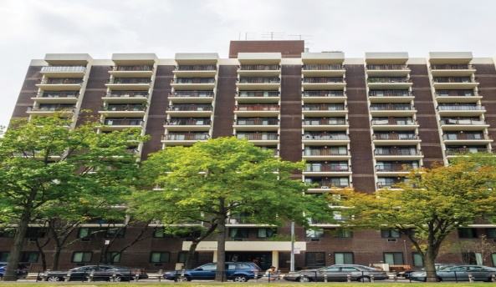

Marien-Heim Tower, Kings County

  - $129.7 million in HOME funds annually help build affordable rental housing & support homeownership across New York state

- Protect & Expand HUD Programs in New York
  - Increased HUD funding is needed to meet growing affordable housing needs
    - 91,897 homeless New Yorkers, including more than 30,000 children
    - 1 million severely rent burdened New York families
    - 3 out of 5 senior New York renter households are rent burdened

  - Investment pays off with proven statewide annual economic benefits of affordable housing production:
    - 26,000 apartments
    - 66,000 jobs
    - $11 billion in local income

HUD. 2019. Picture of Subsidized Households.
Ibid. Specifically units subsidized under the following programs: Section 8 Project Based Voucher program, 202 Supportive Housing for the Elderly program, and 811 Supportive Housing for Persons with Disabilities program.
HUD. 2019. HUD Awards and Allocations.
Ibid.
HUD. 2019. NY 2018 CoC Homeless Assistance Programs Homeless Populations and Subpopulations.
US Census Bureau. 2018. 2016 American Community Survey 1-Year Estimates.
Ibid.
HR&A Advisors, Inc. 2017. Economic Impacts of Affordable Housing on New York State’s Economy. Prepared for NYSAFAH.

