- HUD Investment in Families & Communities
  - 116,323 District Residents use HUD Programs

    - 17,285 Section 8 Vouchers help 34,062 family members afford market rent
    - 30,696 Public Housing Units house 65,359 residents
    - 10,562 privately owned HUD-Assisted units serve 16,902 residents

  - $315.3 million in CDBG funds annually support statewide community initiatives
Affordable Housing Preservation and Development Across Brooklyn

Catholic Charities of Brooklyn and Queens preserved 154 units and created an additional 82 units of affordable housing set aside for tenants with incomes at or below 60% AMI across three sites in Prospect Heights (St. Joseph’s), Bedford Stuyvesant (Our Lady of Good Counsel) and East Williamsburg (Most Holy Trinity).

Federal investments include 9% Low Income Housing Tax Credits and Project-Based Section 8 under the HUD Rental Assistance Demonstration program.

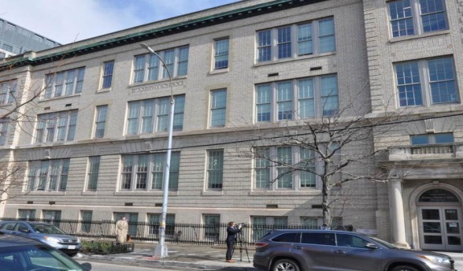
St. Joseph’s, Kings County

  - $129.7 million in HOME funds annually help build affordable rental housing & support homeownership across New York state

- Protect & Expand HUD Programs in New York
  - Increased HUD funding is needed to meet growing affordable housing needs
    - 91,897 homeless New Yorkers, including more than 30,000 children
    - 1 million severely rent burdened New York families
    - 3 out of 5 senior New York renter households are rent burdened

  - Investment pays off with proven statewide annual economic benefits of affordable housing production:
    - 26,000 apartments
    - 66,000 jobs
    - $11 billion in local income

HUD. 2019. Picture of Subsidized Households.
Ibid. Specifically units subsidized under the following programs: Section 8 Project Based Voucher program, 202 Supportive Housing for the Elderly program, 811 Supportive Housing for Persons with Disabilities program, and Moderate Rehabilitation program.
HUD. 2019. HUD Awards and Allocations.
Ibid.
HUD. 2019. NY 2018 CoC Homeless Assistance Programs Homeless Populations and Subpopulations.
US Census Bureau. 2018. 2016 American Community Survey 1-Year Estimates.
Ibid.
HR&A Advisors, Inc. 2017. Economic Impacts of Affordable Housing on New York State’s Economy. Prepared for NYSAFAH.

