- HUD Investment in Families & Communities
  - 99,657 District Residents use HUD Programs

    - 11,697 Section 8 Vouchers help 34,570 family members afford market rent
    - 26,969 Public Housing Units house 56,091 residents
    - 5,350 privately owned HUD-Assisted units serve 8,996 residents

  - $315.3 million in CDBG funds annually support statewide community initiatives
Senior Housing Preservation in Williamsburg

Los Sures Housing for the Elderly revitalized 55 units of affordable housing for seniors with incomes at or below 60% AMI in Williamsburg, Brooklyn. The financing provides much needed improvements for the residing seniors including roofing, exterior masonry work, new kitchens, plumbing and mechanical upgrades.

Federal investments include Tax-Exempt Private Activity Bonds, 4% Low Income Housing Tax Credits and Project-Based Section 8.

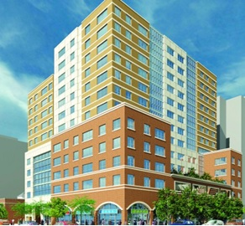
Los Sures, Kings County

  - $129.7 million in HOME funds annually help build affordable rental housing & support homeownership across New York state

- Protect & Expand HUD Programs in New York
  - Increased HUD funding is needed to meet growing affordable housing needs
    - 91,897 homeless New Yorkers, including more than 30,000 children
    - 1 million severely rent burdened New York families
    - 3 out of 5 senior New York renter households are rent burdened

  - Investment pays off with proven statewide annual economic benefits of affordable housing production:
    - 26,000 apartments
    - 66,000 jobs
    - $11 billion in local income

HUD. 2019. Picture of Subsidized Households.
Ibid. Specifically units subsidized under the following programs: Section 8 Project Based Voucher program, 202 Supportive Housing for the Elderly program, 811 Supportive Housing for Persons with Disabilities program, and Moderate Rehabilitation program.
HUD. 2019. HUD Awards and Allocations.
Ibid.
HUD. 2019. NY 2018 CoC Homeless Assistance Programs Homeless Populations and Subpopulations.
US Census Bureau. 2018. 2016 American Community Survey 1-Year Estimates.
Ibid.
HR&A Advisors, Inc. 2017. Economic Impacts of Affordable Housing on New York State’s Economy. Prepared for NYSAFAH.

