- HUD Investment in Families & Communities
  - 8,672 District Residents use HUD Programs

    - 1,594 Section 8 Vouchers help 2,275 family members afford market rent
    - 2,972 Public Housing Units house 5,740 residents
    - 501 privately owned HUD-Assisted units serve 657 residents

  - $315.3 million in CDBG funds annually support statewide community initiatives
Affordable Housing and Economic Development in Jamaica

Macedonia Plaza developed 143 units of affordable housing in a Mixed-Use residential building with 9,000 square feet of new retail space on a former municipal parking lot in Flushing. The affordable housing units are set-aside for low and very low-income New Yorkers. The retail space which includes a grocery store provides new economic opportunity for the area. The new 14-story rental building is also LEED Silver certified.

Federal investments include Tax-Exempt Private Activity Bonds, 4% Low Income Housing Tax Credits and HOME funding.

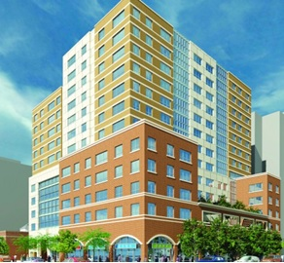
Macedonia Plaza, Queens County

  - $129.7 million in HOME funds annually help build affordable rental housing & support homeownership across New York state

- Protect & Expand HUD Programs in New York
  - Increased HUD funding is needed to meet growing affordable housing needs
    - 91,897 homeless New Yorkers, including more than 30,000 children
    - 1 million severely rent burdened New York families
    - 3 out of 5 senior New York renter households are rent burdened

  - Investment pays off with proven statewide annual economic benefits of affordable housing production:
    - 26,000 apartments
    - 66,000 jobs
    - $11 billion in local income

HUD. 2019. Picture of Subsidized Households.
Ibid. Specifically units subsidized under the following programs: Section 8 Project Based Voucher program, 202 Supportive Housing for the Elderly program, 811 Supportive Housing for Persons with Disabilities program.
HUD. 2019. HUD Awards and Allocations.
Ibid.
HUD. 2019. NY 2018 CoC Homeless Assistance Programs Homeless Populations and Subpopulations.
US Census Bureau. 2018. 2016 American Community Survey 1-Year Estimates.
Ibid.
HR&A Advisors, Inc. 2017. Economic Impacts of Affordable Housing on New York State’s Economy. Prepared for NYSAFAH.

