- HUD Investment in Families & Communities
  - 14,215 District Residents use HUD Programs

    - 4,158 Section 8 Vouchers help 7,832 family members afford market rent
    - 1,935 Public Housing Units house 2,519 residents
    - 2,414 privately owned HUD-Assisted units serve 3,864 residents

  - $315.3 million in CDBG funds annually support statewide community initiatives
Affordable Housing Development in
Valley Stream

Brooke Pointe created 39 affordable units in Valley Stream. The development will be Mixed Income with incomes ranging from low to moderate. Six units will be set aside for tenants with physical disabilities and another two units will be set aside for tenants with vision or hearing disabilities. Tenants will have access to a community room, fitness center, and supportive services.

Federal Investments include 9% Low Income Housing Tax Credits and HOME funding.

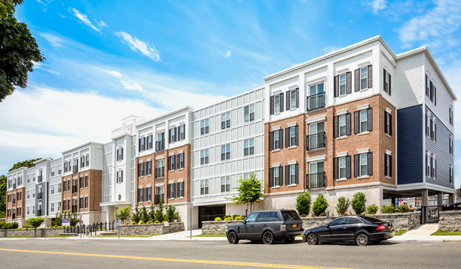
Brooke Pointe, Nassau County

  - $129.7 million in HOME funds annually help build affordable rental housing & support homeownership across New York state

- Protect & Expand HUD Programs in New York
  - Increased HUD funding is needed to meet growing affordable housing needs
    - 91,897 homeless New Yorkers, including more than 30,000 children
    - 1 million severely rent burdened New York families
    - 3 out of 5 senior New York renter households are rent burdened

  - Investment pays off with proven statewide annual economic benefits of affordable housing production:
    - 26,000 apartments
    - 66,000 jobs
    - $11 billion in local income

HUD. 2019. Picture of Subsidized Households.
Ibid. Specifically units subsidized under the following programs: Section 8 Project Based Voucher program, 202 Supportive Housing for the Elderly program, 811 Supportive Housing for Persons with Disabilities program.
HUD. 2019. HUD Awards and Allocations.
Ibid.
HUD. 2019. NY 2018 CoC Homeless Assistance Programs Homeless Populations and Subpopulations.
US Census Bureau. 2018. 2016 American Community Survey 1-Year Estimates.
Ibid.
HR&A Advisors, Inc. 2017. Economic Impacts of Affordable Housing on New York State’s Economy. Prepared for NYSAFAH.

