- HUD Investment in Families & Communities
  - 5,723 District Residents use HUD Programs

    - 1,662 Section 8 Vouchers help 3,012 family members afford market rent
    - 910 Public Housing Units house 1,159 residents
    - 1,242 privately owned HUD-Assisted units serve 1,552 residents

  - $315.3 million in CDBG funds annually support statewide community initiatives
Preservation of Affordable Housing in
North Hempstead

Pond View Homes preserved a 52-unit affordable housing complex on High Street with a massive renovation of the buildings and grounds to address infrastructure problems and modernize the units. Among the 52 units are seven prepared for residents with mobility impairment and three for those with hearing or vision impairment.

Federal Investments include Private Activity Bonds, 4% Low Income Housing Tax Credits and HOME funding.

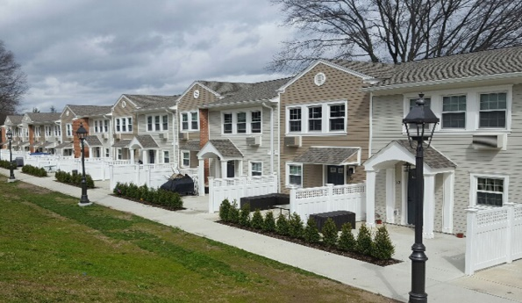
Pond View Apartments, Nassau County

  - $129.7 million in HOME funds annually help build affordable rental housing & support homeownership across New York state

- Protect & Expand HUD Programs in New York
  - Increased HUD funding is needed to meet growing affordable housing needs
    - 91,897 homeless New Yorkers, including more than 30,000 children
    - 1 million severely rent burdened New York families
    - 3 out of 5 senior New York renter households are rent burdened

  - Investment pays off with proven statewide annual economic benefits of affordable housing production:
    - 26,000 apartments
    - 66,000 jobs
    - $11 billion in local income

HUD. 2018. Picture of Subsidized Households.
Ibid. Specifically units subsidized under the following programs: Section 8 Project Based Voucher program, 202 Supportive Housing for the Elderly program, and 811 Supportive Housing for Persons with Disabilities program.
HUD. 2019. HUD Awards and Allocations.
Ibid.
HUD. 2019. NY 2018 CoC Homeless Assistance Programs Homeless Populations and Subpopulations.
US Census Bureau. 2018. 2016 American Community Survey 1-Year Estimates.
Ibid.
HR&A Advisors, Inc. 2017. Economic Impacts of Affordable Housing on New York State’s Economy. Prepared for NYSAFAH.

