- HUD Investment in Families & Communities
  - 44,553 District Residents use HUD Programs

    - 13,405 Section 8 Vouchers help 26,548 family members afford market rent
    - 5,563 Public Housing Units house 8,789 residents
    - 6,608 privately owned HUD-Assisted units serve 9,216 residents

  - $315.3 million in CDBG funds annually support statewide community initiatives
Workforce Housing Preservation in Buffalo

Mariner Towers rehabilitated and preserved 292 units of existing Section 8 affordable housing set aside for households with incomes at or below 60% AMI in Buffalo. The substantial rehabilitation included new kitchens, Energy Star appliances, baths, windows and doors, flooring, roofs, elevators, and masonry work. Health and safety issues were addressed with the installation of a sprinkler system and extensive environmental abatement in all buildings and grounds.

Federal investments include Low Income Housing Tax Credits, Tax-Exempt Housing Bonds, Section 8, HOME, and an FHLB award.

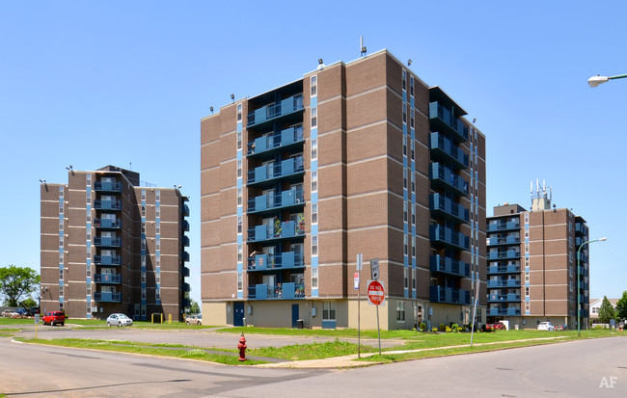Mariner Towers, Erie County

  - $129.7 million in HOME funds annually help build affordable rental housing & support homeownership across New York state

- Protect & Expand HUD Programs in New York
  - Increased HUD funding is needed to meet growing affordable housing needs
    - 91,897 homeless New Yorkers, including more than 30,000 children
    - 1 million severely rent burdened New York families
    - 3 out of 5 senior New York renter households are rent burdened

  - Investment pays off with proven statewide annual economic benefits of affordable housing production:
    - 26,000 apartments
    - 66,000 jobs
    - $11 billion in local income

HUD. 2019. Picture of Subsidized Households.
Ibid. Specifically units subsidized under the following programs: Section 8 Project Based Voucher program, 202 Supportive Housing for the Elderly program, 811 Supportive Housing for Persons with Disabilities program, and Moderate Rehabilitation program.
HUD. 2019. HUD Awards and Allocations.
Ibid.
HUD. 2019. NY 2018 CoC Homeless Assistance Programs Homeless Populations and Subpopulations.
US Census Bureau. 2018. 2016 American Community Survey 1-Year Estimates.
Ibid.
HR&A Advisors, Inc. 2017. Economic Impacts of Affordable Housing on New York State’s Economy. Prepared for NYSAFAH.

