- HUD Investment in Families & Communities
  - 26,541 District Residents use HUD Programs

    - 8,876 Section 8 Vouchers help 16,735 family members afford market rent
    - 2,363 Public Housing Units house 4,557 residents
    - 4,313 privately owned HUD-Assisted units serve 5,249 residents

  - $315.3 million in CDBG funds annually support statewide community initiatives
Adaptive Reuse of a Syracuse Factory into Affordable Housing

Harbor Street Lofts is a former 100-year old knitting factory on Syracuse’s West Side that has been rehabilitated and transformed into a 40 unit mixed-income apartment complex for Syracuse families. 35 apartments are reserved for very low to low income tenants. The remaining five apartments are market rate. The four-story building includes a common laundry area, elevator, play area, community room, computer lab, storage area, and fitness room.

Federal investments include 9% Low Income Housing Tax Credits and HOME funding.

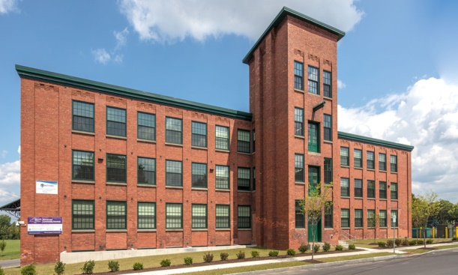Harbor Street Lofts, Onondaga County

  - $129.7 million in HOME funds annually help build affordable rental housing & support homeownership across New York state

- Protect & Expand HUD Programs in New York
  - Increased HUD funding is needed to meet growing affordable housing needs
    - 91,897 homeless New Yorkers, including more than 30,000 children
    - 1 million severely rent burdened New York families
    - 3 out of 5 senior New York renter households are rent burdened

  - Investment pays off with proven statewide annual economic benefits of affordable housing production:
    - 26,000 apartments
    - 66,000 jobs
    - $11 billion in local income

HUD. 2019. Picture of Subsidized Households.
Ibid. Specifically units subsidized under the following programs: Section 8 Project Based Voucher program, 202 Supportive Housing for the Elderly program, and 811 Supportive Housing for Persons with Disabilities program.
HUD. 2019. HUD Awards and Allocations.
Ibid.
HUD. 2019. NY 2018 CoC Homeless Assistance Programs Homeless Populations and Subpopulations.
US Census Bureau. 2018. 2016 American Community Survey 1-Year Estimates.
Ibid.
HR&A Advisors, Inc. 2017. Economic Impacts of Affordable Housing on New York State’s Economy. Prepared for NYSAFAH.

