- HUD Investment in Families & Communities
  - 21,616 District Residents use HUD Programs

    - 8,130 Section 8 Vouchers help 15,038 family members afford market rent
    - 1,851 Public Housing Units house 2,872 residents
    - 2,783 privately owned HUD-Assisted units serve 3,706 residents

  - $315.3 million in CDBG funds annually support statewide community initiatives
Workforce Housing &
Revitalization Project in Ithaca

210 Hancock Street is a Mixed-Income and Mixed-Use Revitalization project that involved the demolition of two underutilized buildings and the construction of 59 new rental units in Ithaca. The site also includes the reconstruction of two city streets. Inside part of the new commercial space will be a Head Start facility serving the community’s children.

Federal Investment includes 9% Low Income Housing Tax Credits, HOME and CDBG funding.

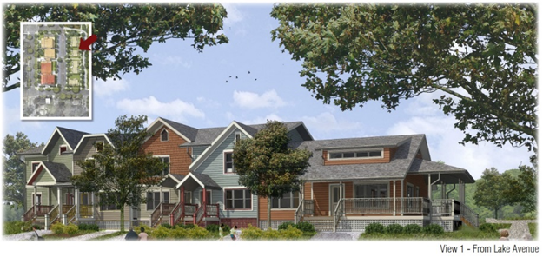 210 Hancock Street, Tompkins County

  - $129.7 million in HOME funds annually help build affordable rental housing & support homeownership across New York state

- Protect & Expand HUD Programs in New York
  - Increased HUD funding is needed to meet growing affordable housing needs
    - 91,897 homeless New Yorkers, including more than 30,000 children
    - 1 million severely rent burdened New York families
    - 3 out of 5 senior New York renter households are rent burdened

  - Investment pays off with proven statewide annual economic benefits of affordable housing production:
    - 26,000 apartments
    - 66,000 jobs
    - $11 billion in local income

HUD. 2019. Picture of Subsidized Households.
Ibid. Specifically units subsidized under the following programs: Section 8 Project Based Voucher program, 202 Supportive Housing for the Elderly program, and 811 Supportive Housing for Persons with Disabilities program.
HUD. 2019. HUD Awards and Allocations.
Ibid.
HUD. 2019. NY 2018 CoC Homeless Assistance Programs Homeless Populations and Subpopulations.
US Census Bureau. 2018. 2016 American Community Survey 1-Year Estimates.
Ibid.
HR&A Advisors, Inc. 2017. Economic Impacts of Affordable Housing on New York State’s Economy. Prepared for NYSAFAH. http://www.nysafah.org/cmsBuilder/uploads/nysafah-economic-impact-of-affordable-housing-2017-update-(2011-2015)-final-(003).pdf

