- HUD Investment in Families & Communities
  - 18,642 District Residents use HUD Programs

    - 6,090 Section 8 Vouchers help 9,641 family members afford market rent
    - 2,369 Public Housing Units house 4,465 residents
    - 3,514 privately owned HUD-Assisted units serve 4,536 residents
Affordable Housing Development in Union

Cardinal Cove Apartments is comprised of 50 affordable units in 25 duplex buildings and a separate community building. The town experienced severe flooding in 2006 and 2011, resulting in the loss of much of its affordable housing. Preference in occupancy for the project will be given to households directly affected by the flooding. In addition to providing much-needed affordable housing, by keeping families in the area the Cardinal Cove will help to stabilize the neighborhood’s commercial center. The site includes a playground, and on-site storm water detention system.

Federal Investment includes 9% Low Income Housing Tax Credits and CDBG-DR funding.

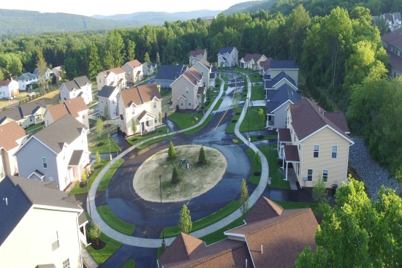 Cardinal Cove Apartments, Broome County

  - $315.3 million in CDBG funds annually support statewide community initiatives

  - $129.7 million in HOME funds annually help build affordable rental housing & support homeownership across New York state

- Protect & Expand HUD Programs in New York
  - Increased HUD funding is needed to meet growing affordable housing needs
    - 91,897 homeless New Yorkers, including more than 30,000 children
    - 1 million severely rent burdened New York families
    - 3 out of 5 senior New York renter households are rent burdened

  - Investment pays off with proven statewide annual economic benefits of affordable housing production:
    - 26,000 apartments
    - 66,000 jobs
    - $11 billion in local income

HUD. 2019. Picture of Subsidized Households.
Ibid. Specifically units subsidized under the following programs: Section 8 Project Based Voucher program, 202 Supportive Housing for the Elderly program, and 811 Supportive Housing for Persons with Disabilities program.
HUD. 2019. HUD Awards and Allocations.
Ibid.
HUD. 2019. NY 2018 CoC Homeless Assistance Programs Homeless Populations and Subpopulations.
US Census Bureau. 2018. 2016 American Community Survey 1-Year Estimates.
Ibid.
HR&A Advisors, Inc. 2017. Economic Impacts of Affordable Housing on New York State’s Economy. Prepared for NYSAFAH.

