- HUD Investment in Families & Communities
  - 30,087 District Residents use HUD Programs

    - 8,769 Section 8 Vouchers help 16,760 family members afford market rent
    - 4,033 Public Housing Units house 7,391 residents
    - 4,579 privately owned HUD-Assisted units serve 5,936 residents
Adaptive Reuse and Senior Affordable Housing Development in Schenectady

13 State Street has been converted from a historic YMCA building into 61 senior affordable apartments located strategically near the Mohawk River waterfront, the Stockade District and downtown Schenectady. In addition to the apartments and first floor commercial space, the building will feature a community room, fitness center, kitchen, library/computer room and a multi-purpose room.

Federal Investment includes Private Activity bonds, 4% Low Income Housing Tax Credits, Historic Tax Credits, and CDBG-DR funding.

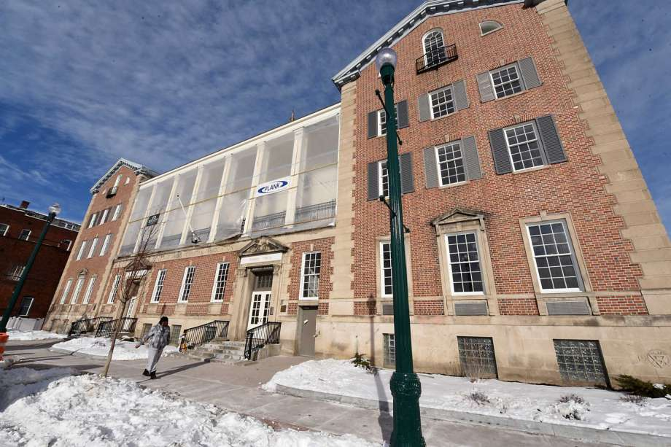
13 State Street, Schenectady County

  - $315.3 million in CDBG funds annually support statewide community initiatives

  - $129.7 million in HOME funds annually help build affordable rental housing & support homeownership across New York state

- Protect & Expand HUD Programs in New York
  - Increased HUD funding is needed to meet growing affordable housing needs
    - 91,897 homeless New Yorkers, including more than 30,000 children
    - 1 million severely rent burdened New York families
    - 3 out of 5 senior New York renter households are rent burdened

  - Investment pays off with proven statewide annual economic benefits of affordable housing production:
    - 26,000 apartments
    - 66,000 jobs
    - $11 billion in local income

HUD. 2019. Picture of Subsidized Households.
Ibid. Specifically units subsidized under the following programs: Section 8 Project Based Voucher program, 202 Supportive Housing for the Elderly program, 811 Supportive Housing for Persons with Disabilities program, and Moderate Rehabilitation program.
HUD. 2019. HUD Awards and Allocations.
Ibid.
HUD. 2019. NY 2018 CoC Homeless Assistance Programs Homeless Populations and Subpopulations.
US Census Bureau. 2018. 2016 American Community Survey 1-Year Estimates.
Ibid.
HR&A Advisors, Inc. 2017. Economic Impacts of Affordable Housing on New York State’s Economy. Prepared for NYSAFAH.

