- HUD Investment in Families & Communities
  - 9,000 District Residents use HUD Programs.

    - 3,725 Section 8 Vouchers help 7816 family members afford market rent
    - 369 Public Housing Units house 407 residents
    - 701 privately owned HUD-Assisted units serve 777 residents

  - $315.3 million in CDBG funds annually support statewide community initiatives
Workforce Housing in Babylon

Copiague Commons has aided Copiague’s post-Sandy downtown revitalization. Two 4-story buildings offer 90 units of affordable housing in one of New York’s high cost suburban areas. 71 rentals are reserved for low-income families earning up to 60% of area median income and 18 are for middle income families.

Federal investment includes Private Activity Bonds, 4 % Low Income Housing Tax Credits and CDBG-DR funding.

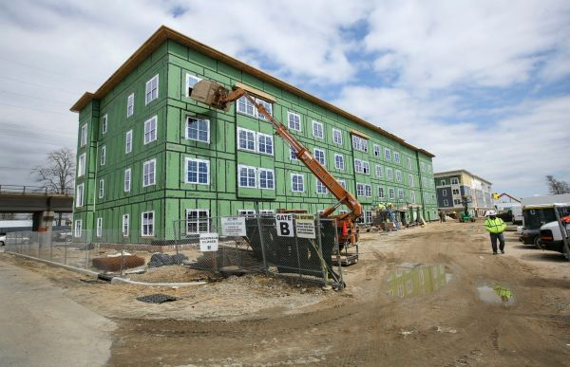 Copiague Commons, Suffolk County

  - $129.7 million in HOME funds annually help build affordable rental housing & support homeownership across New York state

- Protect & Expand HUD Programs in New York
  - Increased HUD funding is needed to meet growing affordable housing needs.
    - 91,897 homeless New Yorkers, including more than 30,000 children
    - 1 million severely rent burdened New York families
    - 3 out of 5 senior New York renter households are rent burdened

  - Investment pays off with proven statewide annual economic benefits of affordable housing production:
    - 26,000 apartments
    - 66,000 jobs
    - $11 billion in local income

HUD. 2019. Picture of Subsidized Households.
Ibid. Specifically units subsidized under the following programs: Section 8 Project Based Voucher program, 202 Supportive Housing for the Elderly program, and 811 Supportive Housing for Persons with Disabilities program.
HUD. 2019. HUD Awards and Allocations.
Ibid.
HUD. 2019. NY 2018 CoC Homeless Assistance Programs Homeless Populations and Subpopulations.
US Census Bureau. 2018. 2016 American Community Survey 1-Year Estimates.
Ibid.
HR&A Advisors, Inc. 2017. Economic Impacts of Affordable Housing on New York State’s Economy. Prepared for NYSAFAH.

