- HUD Investment in Families & Communities
  - 17,516 District Residents use HUD Programs

    - 6,680 Section 8 Vouchers help 12,754 family members afford market rent
    - 713 Public Housing Units house 1,405 residents
    - 2,316 privately owned HUD-Assisted units serve 3,357 residents
Senior Affordable Housing Preservation in Liberty

The Golden Park Apartments project involves renovation of 126 senior apartments housed in 10 existing 2-story buildings at Golden Park in Liberty, NY. Golden Park provides affordable housing for low-income senior citizens and the disabled with spacious one-bedroom floor plans and a community center.

Federal investments include Tax-Exempt Private Activity Bonds, 4% Low Income Housing Tax Credits and Project-based Section 8 under the HUD Rental Assistance Demonstration program.

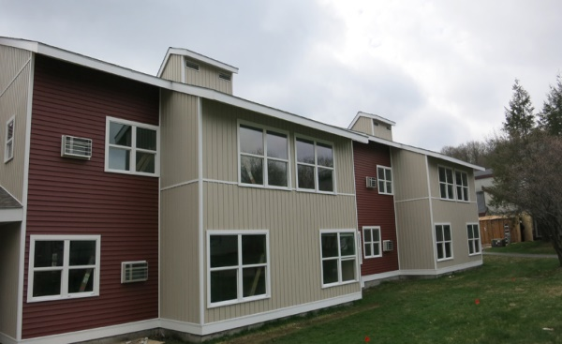
Golden Park Apartments, Sullivan County

  - $315.3 million in CDBG funds annually support statewide community initiatives

  - $129.7 million in HOME funds annually help build affordable rental housing & support homeownership across New York state

- Protect & Expand HUD Programs in New York
  - Increased HUD funding is needed to meet growing affordable housing needs
    - 91,897 homeless New Yorkers, including more than 30,000 children
    - 1 million severely rent burdened New York families
    - 3 out of 5 senior New York renter households are rent burdened

  - Investment pays off with proven statewide annual economic benefits of affordable housing production:
    - 26,000 apartments
    - 66,000 jobs
    - $11 billion in local income

HUD. 2019. Picture of Subsidized Households.
Ibid. Specifically units subsidized under the following programs: Section 8 Project Based Voucher program, 202 Supportive Housing for the Elderly program, and 811 Supportive Housing for Persons with Disabilities program.
HUD. 2019. HUD Awards and Allocations.
Ibid.
HUD. 2019. NY 2018 CoC Homeless Assistance Programs Homeless Populations and Subpopulations.
US Census Bureau. 2018. 2016 American Community Survey 1-Year Estimates.
Ibid.
HR&A Advisors, Inc. 2017. Economic Impacts of Affordable Housing on New York State’s Economy. Prepared for NYSAFAH.

