- HUD Investment in Families & Communities
  - 24,775 District Residents use HUD Programs

    - 6,607 Section 8 Vouchers help 11,464 family members afford market rent
    - 5,766 Public Housing Units house 10,397 residents
    - 2,153 privately owned HUD-Assisted units serve 2,914 residents

  - $315.3 million in CDBG funds annually support statewide community initiatives
Preservation of Affordable Senior Housing

Renovations to Scheuer Gardens and Plaza preserved 250 apartments and two buildings on Barker Avenue. The fully occupied apartment buildings provide affordable apartments for seniors and the disabled as part of the HUD 202 supportive housing program were built in the 1980s. Among the improvements are new kitchen fixtures, windows and gym rooms, as well as enhancements and renovations to a game room, lobbies, garden landscaping, the exteriors of the buildings, and roof terrace.

Other federal investments include Tax-Exempt Private Activity Bonds and 4% Low Income Housing Tax Credits.

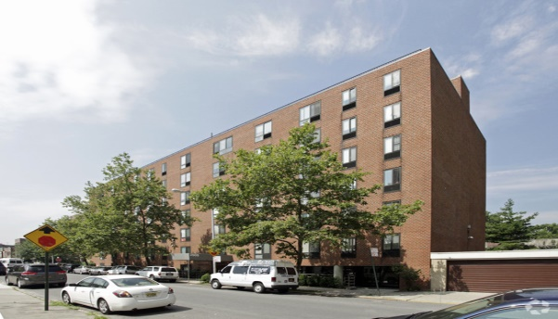
Scheuer Plaza, Bronx County

  - $129.7 million in HOME funds annually help build affordable rental housing & support homeownership across New York state

- Protect & Expand HUD Programs in New York
  - Increased HUD funding is needed to meet growing affordable housing needs
    - 91,897 homeless New Yorkers, including more than 30,000 children
    - 1 million severely rent burdened New York families
    - 3 out of 5 senior New York renter households are rent burdened

  - Investment pays off with proven statewide annual economic benefits of affordable housing production:
    - 26,000 apartments
    - 66,000 jobs
    - $11 billion in local income

HUD. 2019. Picture of Subsidized Households.
Ibid. Specifically units subsidized under the following programs: Section 8 Project Based Voucher program, 202 Supportive Housing for the Elderly program, 811 Supportive Housing for Persons with Disabilities program, and Moderate Rehabilitation program.
HUD. 2019. HUD Awards and Allocations.
Ibid.
HUD. 2019. NY 2018 CoC Homeless Assistance Programs Homeless Populations and Subpopulations.
US Census Bureau. 2018. 2016 American Community Survey 1-Year Estimates.
Ibid.
HR&A Advisors, Inc. 2017. Economic Impacts of Affordable Housing on New York State’s Economy. Prepared for NYSAFAH.

