- HUD Investment in Families & Communities
  - 32,310 District Residents use HUD Programs

    - 6,336 Section 8 Vouchers help 12,557 family members afford market rent
    - 5,805 Public Housing Units house 12,592 residents
    - 4,145 privately owned HUD-Assisted units serve 7,161 residents

  - $315.3 million in CDBG funds annually support statewide community initiatives
Preservation of Affordable Housing in
Staten Island

Fox Hill Apartments rehabilitated and preserved 3 affordable apartment buildings. 362 of the 364 of the apartments are under Project-based Section 8 contract. The scope of rehabilitation included, but was not limited to new roofs, new windows, new boiler, bathroom and kitchen upgrades, elevator overhaul, corridor, and lobby improvements.

Federal investments include Tax-Exempt Private Activity bonds and 4% Low Income Housing Tax Credits.

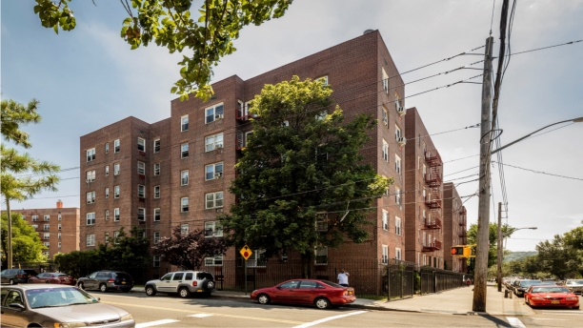
Fox Hill Apartments, Richmond County

  - $129.7 million in HOME funds annually help build affordable rental housing & support homeownership across New York state

- Protect & Expand HUD Programs in New York
  - Increased HUD funding is needed to meet growing affordable housing needs
    - 91,897 homeless New Yorkers, including more than 30,000 children
    - 1 million severely rent burdened New York families
    - 3 out of 5 senior New York renter households are rent burdened

  - Investment pays off with proven statewide annual economic benefits of affordable housing production:
    - 26,000 apartments
    - 66,000 jobs
    - $11 billion in local income

HUD. 2019. Picture of Subsidized Households.
Ibid. Specifically units subsidized under the following programs: Section 8 Project Based Voucher program, 202 Supportive Housing for the Elderly program, and 811 Supportive Housing for Persons with Disabilities program.
HUD. 2019. HUD Awards and Allocations.
Ibid.
HUD. 2019. NY 2018 CoC Homeless Assistance Programs Homeless Populations and Subpopulations.
US Census Bureau. 2018. 2016 American Community Survey 1-Year Estimates.
Ibid.
HR&A Advisors, Inc. 2017. Economic Impacts of Affordable Housing on New York State’s Economy. Prepared for NYSAFAH.

