- HUD Investment in Families & Communities
  - 40,487 District Residents use HUD Programs

    - 8,487 Section 8 Vouchers help 23,164 family members afford market rent
    - 5,810 Public Housing Units house 11,037 residents
    - 4,269 privately owned HUD-Assisted units serve 6,286 residents

  - $315.3 million in CDBG funds annually support statewide community initiatives
Mixed-Income Affordable Development on 42nd Street

605 West 42nd Street Apartments created 235 units of affordable housing in a 1,174 unit building in Hell’s Kitchen. The affordable units will be set aside for tenants with incomes at or below 60%AMI and will remain affordable in perpetuity according to NYC HPD Inclusionary Housing Program guidelines. On-site amenities include a children’s playroom, basketball court, pool, outdoor terrace and community rooms.

With public and private investment of $821.2 Million, the project’s financing includes Tax-Exempt Housing Bonds and LIHTC.

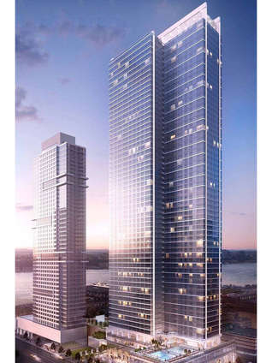
605 West 42nd Street, New York County

  - $129.7 million in HOME funds annually help build affordable rental housing & support homeownership across New York state

- Protect & Expand HUD Programs in New York
  - Increased HUD funding is needed to meet growing affordable housing needs
    - 91,897 homeless New Yorkers, including more than 30,000 children
    - 1 million severely rent burdened New York families
    - 3 out of 5 senior New York renter households are rent burdened

  - Investment pays off with proven statewide annual economic benefits of affordable housing production:
    - 26,000 apartments
    - 66,000 jobs
    - $11 billion in local income

HUD. 2019. Picture of Subsidized Households.
Ibid. Specifically units subsidized under the following programs: Section 8 Project Based Voucher program, 202 Supportive Housing for the Elderly program, and 811 Supportive Housing for Persons with Disabilities program.
HUD. 2019. HUD Awards and Allocations.
Ibid.
HUD. 2019. NY 2018 CoC Homeless Assistance Programs Homeless Populations and Subpopulations.
US Census Bureau. 2018. 2016 American Community Survey 1-Year Estimates.
Ibid.
HR&A Advisors, Inc. 2017. Economic Impacts of Affordable Housing on New York State’s Economy. Prepared for NYSAFAH. http://www.nysafah.org/cmsBuilder/uploads/nysafah-economic-impact-of-affordable-housing-2017-update-(2011-2015)-final-(003).pdf

