- HUD Investment in Families & Communities
  - 11,933 District Residents use HUD Programs

    - 4,920 Section 8 Vouchers help 9,328 family members afford market rent
    - 2,264 privately owned HUD-Assisted units serve 2,605 residents

  - $315.3 million in CDBG funds annually support statewide community initiatives
Affordable Housing in Riverhead

Peconic Crossing created 45 one and two bedroom affordable apartments in downtown Riverhead. The units will be available to very low-income tenants with preferences given to artists and people displaced by certain storms, including Superstorm Sandy. The four story project utilized green building practices. The building will include a community room and ground-level artist gallery for residents to create, collaborate, and live.

Federal Investments include 9% Low Income Housing Tax Credits and CDBG-DR funding.

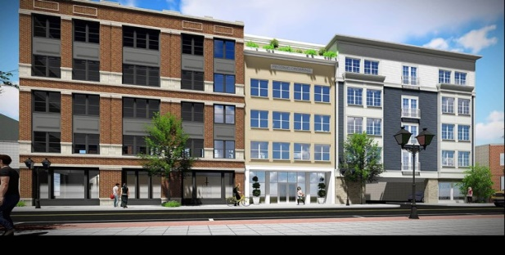 Peconic Crossing, Suffolk County

  - $129.7 million in HOME funds annually help build affordable rental housing & support homeownership across New York state

- Protect & Expand HUD Programs in New York
  - Increased HUD funding is needed to meet growing affordable housing needs
    - 91,897 homeless New Yorkers, including more than 30,000 children
    - 1 million severely rent burdened New York families
    - 3 out of 5 senior New York renter households are rent burdened

  - Investment pays off with proven statewide annual economic benefits of affordable housing production:
    - 26,000 apartments
    - 66,000 jobs
    - $11 billion in local income

HUD. 2019. Picture of Subsidized Households.
Ibid. Specifically units subsidized under the following programs: Section 8 Project Based Voucher program, 202 Supportive Housing for the Elderly program and 811 Supportive Housing for Persons with Disabilities program.
HUD. 2019. HUD Awards and Allocations.
Ibid.
HUD. 2019. NY 2018 CoC Homeless Assistance Programs Homeless Populations and Subpopulations.
US Census Bureau. 2018. 2016 American Community Survey 1-Year Estimates.
Ibid.
HR&A Advisors, Inc. 2017. Economic Impacts of Affordable Housing on New York State’s Economy. Prepared for NYSAFAH.

